**Transceiver Selection**

Given the design choice that minimum number of boards is used for each subsystem, a single transceiver is required to provide both transmitting and receiving abilities. However, many manufacturers only supply transmitters instead of transceivers for S-Band operation. It results very limited options for off-the-self S-Band CubeSat transceiver. The following chart lists the transceiver models that have been viewed for selection.

|  |  |  |  |  |  |  |  |  |  |  |
| --- | --- | --- | --- | --- | --- | --- | --- | --- | --- | --- |
| brand | data rate (kbps) | | transmitted power | supply power (V) | power consumption | | frequency (GHz) | mass (g) |  |  |
|  | Tx | Tx |  |  | Rx | Tx |  |  |  |
| Endurosat | 20000 |  | 2W | 5,12 | 9 |  | 2.2-2.29 |  | transmitter | https://www.endurosat.com/products/cubesat-s-band-transmitter/ |
| Nano Avionics | 100 - 500 | 100 | 20 to 30 dBm | 5-40 | 0.65 | 6.5 (tx+rx) | 2.2-2.30 | 191 | transceiver | https://n-avionics.com/subsystems/s-band-transceiver/ |
| Satlab | 128 - 512 | 128 | 20 to 30 dBm | 5-41 | 0.65 | 5 | 2.2-2.31 | 190 | transceiver | https://www.satlab.com/resources/SLDS-SRS3-1.1.pdf |
| IQ Wireless | 600-40000 |  | 27 dBm | 7 - 18W | 3-4.5 | 8 - 12 W | 2.2-2.32 | 420 | transceiver | http://www.iq-wireless.com/images/pdf/SLINK-Datasheet.pdf |
| ISIS | 3400 |  | 27-33 dBm | 6-20V | 2 | 9 | 2.2-2.30 | <300 | transmitter | https://www.isispace.nl/product/isis-txs-s-band-transmitter/ |

The preliminary power budget given from the power subsystem is 5 to 7W, with this restricted amount of power, it eliminates options for using high power high performance models.

The selected transceiver is the SRS-3 full-duplex low-power s-band transceiver made by Satlab. Although it only supports a maximum transmission rate of 512kpbs, it consumes significantly lower power. It operated in the s-band frequency range 2.2 – 2.32 GHz, and it has integrated transmit and receive filter, low noise amplifier (LNA) and power amplimer.

Figure 1 Satlab SRS-3 transceiver

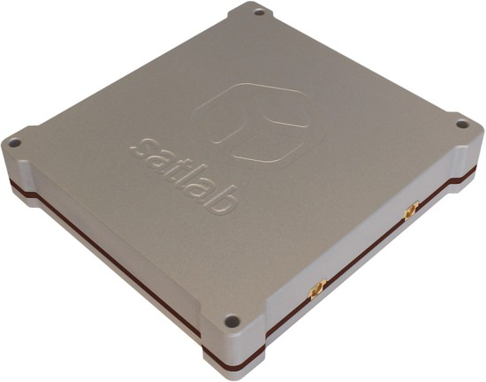

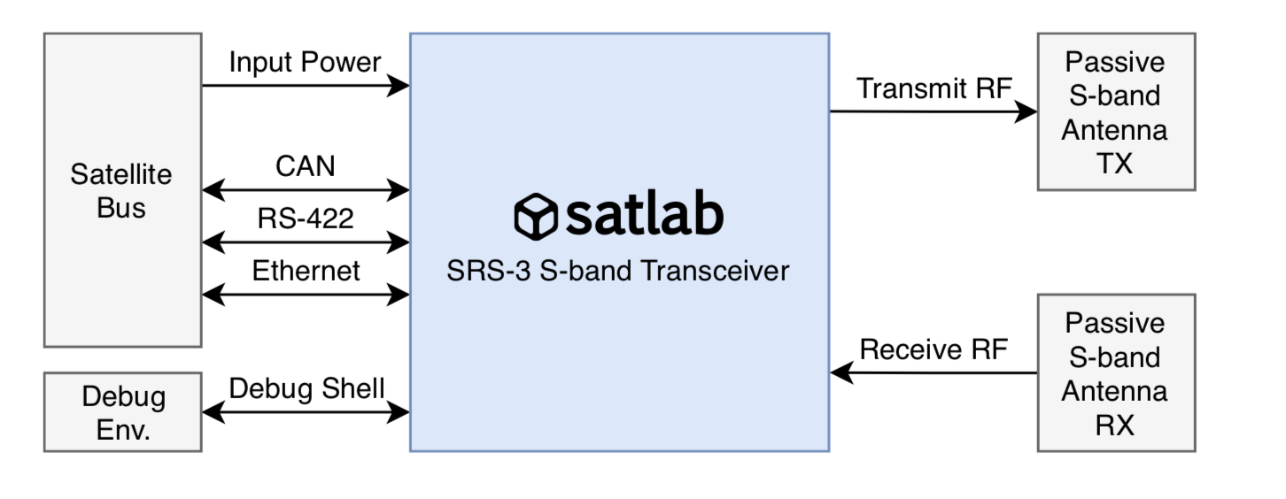

Figure 2 transceiver interface overview

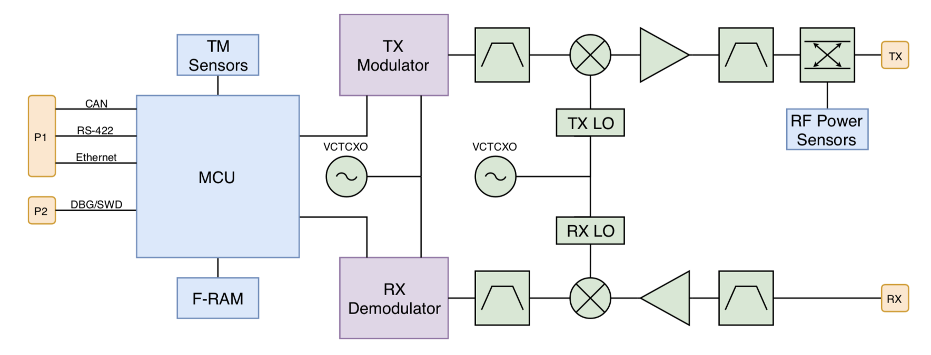

Figure 3 transceiver hardware block diagram

The following chart lists some of the key parameters of the transceiver.

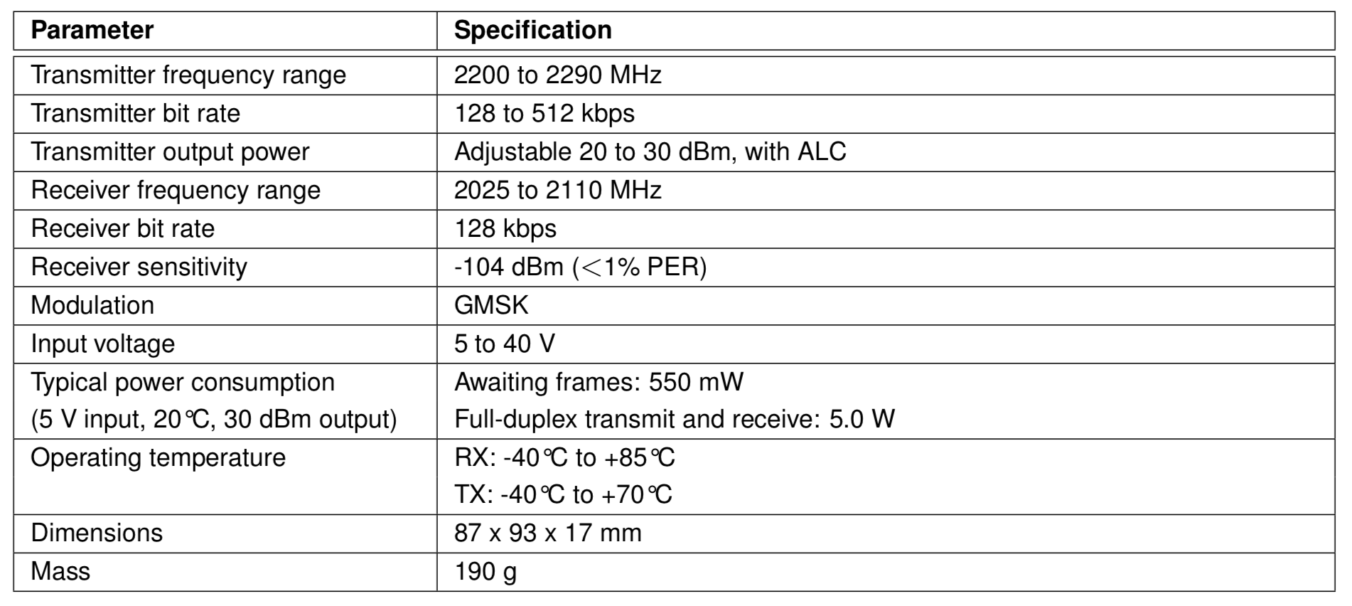

Figure 4 transceiver key parameters